**Database schemas,stored procedures,subtotals**

**Database schema:**

A database schema is a structure that represents the logical storage of the data in a database

Database:

A place to store the data in a structured format.

The schema does not physically contain the data itself; instead, it gives information about the shape of data and how it can be related to other tables or models.

Types of database schema:

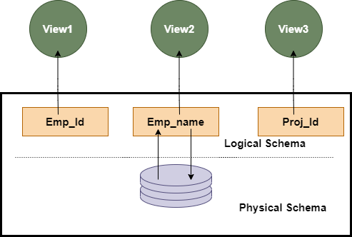

View schema: This schema generally describes the end-user interaction with the database systems.

Logical schema:contains all the logical constraints, it represents how the data is stored in the form of tables and how the attributes of a table are linked together.

Physical schema:how data is stored physically in a stored system.

Create schema : creates a new schema in sql server.

Database scheme designs:

Flat schema: like 2d array contains rows and colums.used for simple applications that doesn’t contain large data.

Hierarchal model:tree like structure ,have parent and child nodes and have one to many relationship

Network model:similar to hierarichal but have many to many relationship .

Relational model:The relational models are used for the relational database, which stores data as relations of the table. There are relational operators used to operate on data to manipulate and calculate different values from it.

Star schema:used for storing and analysing huge amounts of data.has facts and dimensions

**the fact** is the numerical data point that runs business processes, and **Dimension** is a description of fact. With Star Schema, we can structure the data of RDBMS.

Snowflake schema: the star schema that contains the main data points and reference to its dimension tables. But in snowflake, dimension tables can have their own dimension tables.

**Stored procedure:**

A stored procedure is a prepared SQL code that you can save, so the code can be reused over and over again.

So if you have an SQL query that you write over and over again, save it as a stored procedure, and then just call it to execute it.

You can also pass parameters to a stored procedue, so that the stored procedure can act based on the parameter value(s) that is passed.

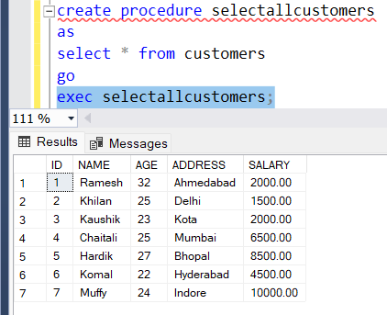

With single parameter:

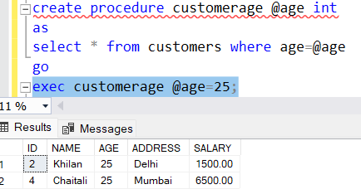

Multiple parametres:

**Subtotal:**

A subtotal is a figure that shows the sum of similar sets of data but it does not indicate the final total.

(For example, if our query returns cities and their populations, grouped by the city’s district and perhaps also grouped by country, it would be nice to include subtotals for each district (based on the aggregate populations of all cities in the district). And it might also be nice to have the total population of each country, based on the same aggregate data.

Another way of putting it is that we want to get a summary of the summary. Or an aggregate of the aggregate. This is sometimes referred to as “super aggregate”.

Fortunately, in MySQL we can use the WITH ROLLUP modifier of the GROUP BY clause to achieve exactly that.)

ROLLUP, CUBE, and GROUPING SETS are extensions of the GROUP BY statement and add the extra subtotal and grand total rows to the resultset.

In order to calculate a subtotal in SQL query, we can use the ROLLUP extension of the GROUP BY statement

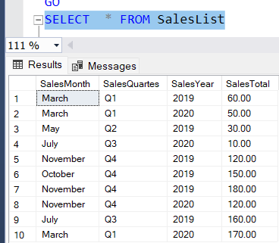

Rollup:

The **ROLLUP** extension allows us to generate hierarchical subtotal rows according to its input columns and it also adds a grand total row to the result set.

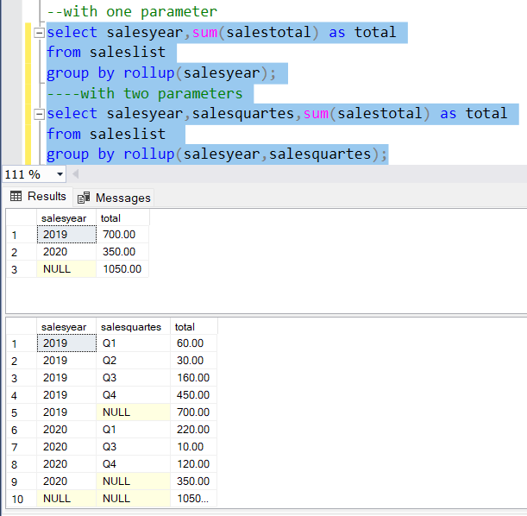

Grouping function:

The GROUPING function is used to determine whether the columns in the GROUP BY list have been aggregated. Therefore, we can use this function to identify the NULL values and replace them.instead of null values we can use other wors to make it more presentable .

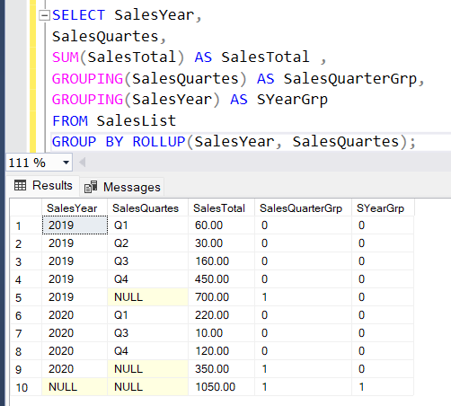

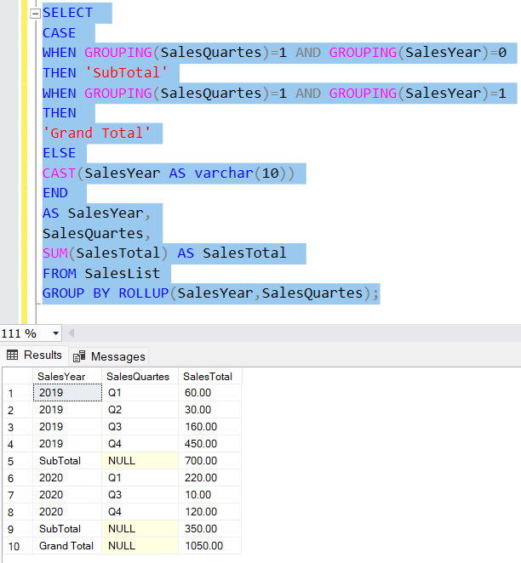

Using cte:

